Name: Sarween Alages

Matric No: 207460

System: Hospital System

1. Package Diagram

1. Component Diagram

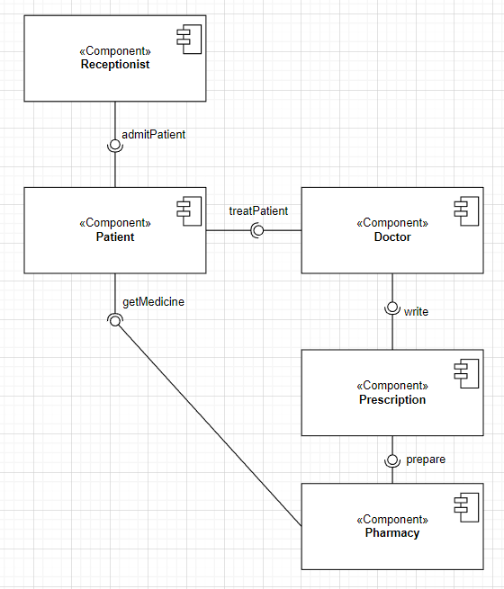

1. Deployment Diagram

In a hotel system, availability and security is important.

**Security**: All patient’s data kept private in the hospital database.

**Availability**: In event of failure, the backup storage takes over, short downtime with about 24 hours availability.

**Architecture style**: Layered architecture

The layers are presentation layer, service layer, and data layer. Each of them are separate so if anyone fails the other layer can continue executing.